Russian political prisoners in the year of 2018: the situation and its trends.

The Human Rights Advocacy Center "Memorial" has been compiling the lists of Russian political prisoners for several years by now.
The term "political prisoner," that we are using is backed up by the PACE Resolution No. 1900 (2012). First of all, these are the cases that can be described by using the reference to the term "prisoner of conscience", when the criminal prosecution or imprisonment has been applied to people solely because of their political, religious or other believes, as well as in conjunction with the non - violent exercise of people’s rights and freedoms, which are guaranteed by the European Convention for the Protection of Human Rights and Fundamental Freedoms.
And second of all, these are the cases of political persecution by the official authorities, carried out in violation of the right to a fair trial and some other rights and freedoms, that are guaranteed by the International Convention for the Protection of Human Rights and Fundamental Freedoms, this persecution is conducted with an obvious violation of the law, on a selective basis, in an inadequate fashion with the public endangerment acts, or on the basis of falsification of the proof of the guilt.
By the notion of "imprisonment / deprivation of freedom" we are implying a detention in correctional facilities, or in some psychiatric institutions on the grounds of a court verdict, a pre-trial detention in custody, or a house arrest before the court sentencing.
At the same token, we exclude from the numbers of political prisoners those individuals, who used violence against another person, or were calling for violence based on the racial, religious, ethnic factors, etc. Naturally, such exclusion does not mean that we consider the persecution of those individuals to be unconditionally justified and legitimate, or that we approve of such prosecution. From this perspective, we do not include in the lists of political prisoners those many other individuals, who were deprived of their freedom, even if formally they had violated the law, but when the punishment applied to them it has been clearly in excess.
In addition, the lists of the political prisoners are obviously incomplete, since they include only those individuals the materials on whom we have been able to analyze and assess from the criminal prosecution legitimacy point of view for procedural compliance based on our criteria. However, for various reasons, and particularly due to the secret nature of the persecution in the cases of espionage, high treason and multiple cases on terrorism, a great deal of criminally prosecuted cases that appear to have traces of lawlessness and political motivation have not been not included in the present list.
Thusly, by the proper virtue of the very notion of "political prisoner" itself there naturally is a vast array of criminal political repressions in place, which are not linked to imprisonment at the present moment, and which have been left outside our statistical data.
For the foregoing reasons, the lists of political prisoners of the Human Rights Advocacy Center "Memorial" present by itself a minimal conservative estimate of the number of political prisoners detained in Russia, and they are just an indicator of the level of political repression in place in general. Most likely the total number of political prisoners exceeds the lists of those who are kept on the records at the Memorial Human Rights Advocacy Center by 2 - 3 times.
Nevertheless, these lists provide us with an opportunity of getting an idea about what the situation is like, its trends and the changes happening within it.
Starting from 2016, and after having taken into consideration the great deal of criminal prosecution cases in conjunction with the people carrying out their right to the freedom of practicing their religion and choosing their religious affiliations, especially in regards to the Muslims, first & foremost, we are publishing the two lists: a list of individuals, who were deprived of their freedom because of their execution of their right to freedom of religion and religious affiliation, and another list for all the other political prisoners.
And whatever we had to say about the fact that two lists are virtually not complete pertains equally to the both of them.
There were 46 people on the list of political prisoners as of September 1, 2018, (except for those ones, who were persecuted in conjunction with the exercise of their right to freedom of religion and religious affiliation). There are 137 people on the "religious" list. All in all the total is 183 people.
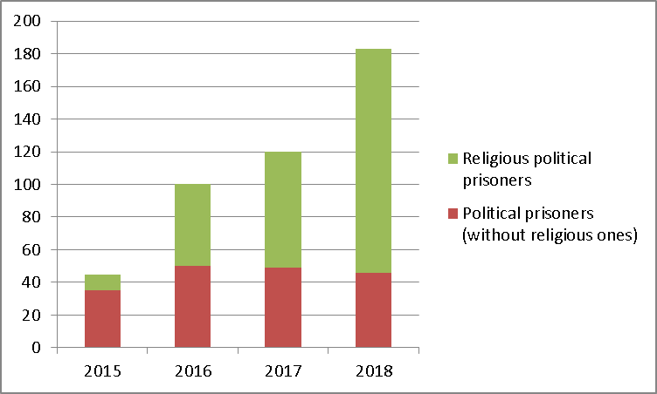
Diagram 1.

In the recent years we have observed that the number of political prisoners has been steadily on the rise, and especially noticeable is the fact that the growth is occurring due to number of individuals, who are being persecuted in conjunction with the execution of their right to the freedom of practicing their religion. At the same time, the number of the other political prisoners remains more or less at the same level.
There were 49 names on the "generic" list of political prisoners a year ago, and the total number of political prisoners consisted of 120 people, two and three years ago the numbers were - 50 (100), and 35 (45) people, respectively.
In general, after taking into consideration all of those, who had been freed & released during this timeframe, the number of political prisoners in Russia for the last year was equal to 71 people on the "general" list. And also there were 142 individuals placed on the list of people, who had been deprived of their freedom in connection with them exercising their right to freedom of religion and religious affiliations. All in all, there were 213 people in total, who got included in the lists of the HRAC "Memorial" during that year.
Throughout the duration of the last year, starting with the past September, 25 people from the "general" list of political prisoners, who were among those defendants, who got implicated in some cases, were released, (5 of those were included in the list during the last year).
Out of that number 14 people (I. Barylyak, Z. Bagavutdinova, D. Borisov, R. Kashapov, A. Kostenko, Y. Kuliy, A. Kungurov, R. Kutayev, S. Nikiforov, V. Parfenov, D. Polyudova, A. Sokolov, V. Sokolov, A. Eyvazov) have already served their complete terms, one of them (A. Nikonorov) was released on parole, and another one (M. Panfilov) was released after the application of compulsory measures of a medical nature. The term of I. Tutisani's imprisonment punishment was reduced due to the revisions made in his case, which factually almost happened at the time the term was actually up, (D. Buchenkov) ran away from the house arrest and emigrated to one of the EU countries, five others (A. Asanov, M. Galperin, M.D. Germendzhi. V. Egorov,) got their vacating measure of restraint lifted, two more (I. Umerov, A. Chiygoz) were pardoned, and as far as another political prisoner (D. Bogatov) is concerned, the case against him was closed.
Unfortunately, by that time the list has already been prolongated by 22 more names of the new individuals added to it: D. Bauldin, D. Bogatov, M. Dadeu, I. Ivanov, A. Mamaev, R.Maryan, P. Miloserdov, A. Orshulevich, V. Prisich, I.I. Rudnikov, M. Savostin, K. Saltykov, N. Sentsov, Y. Sidorov, V. Sokolov, O. Titiiev, D. Tretyakov, M. Tsakunov, G. Shabliy, V. Shatrovsky, A. Shumkov, A. Eyvazov.
Just as it used to be the case before, there are the citizens of Ukraine and Russia placed among the political prisoners, who have been convicted in conjunction with the anti - Ukrainian campaign waged by the Russian government. Among those individuals, who have made it on the list of political prisoners during the last year we have: D. Baholdin, M. Dadeu, A. Shumkov, who are persecuted based on charges of their alleged participation in the organization "Right Sector," which is operating on the Ukrainian territory. V. Prisich and G. Shabliy, who have become hostages of the campaign that is aimed at searching for Ukrainian "saboteurs and reconnaissance" in the Crimea.
All in all, there are 13 of such individuals on the "general" list of political prisoners (in addition to the 28 people, who had been deprived of their freedom / imprisoned in the Crimea based on charges brought against them claiming their alleged participation in “Hizb ut-Tahrir”). And that is just one fractural part of all of the Ukrainian hostages kept in Russia. Oleg Sentsov has been demanding their release for 121 days by going on a hunger strike protest. We are certain, that out of that number of those people, who are representing Ukrainian hostages in Russia, and whom we could not have yet gotten to be included in the list of political prisoners due to the various reasons and substantiated grounds, there are some hostages, who, on the one hand, have been stripped of their freedom in the consequential result of the situation that came into being due to the aggression waged by the Russian official authorities against Ukraine, and who, on the other hand, have been deprived of their right to a fair trial in Russia as well.
Based on the charges brought against them in conjunction with them executing their right to the freedom of expression over the Internet - D. Bogatov, P. Miloserdov, V. Sokolov, D. Tretyakov have been persecuted last year, therefore making an addition to the list of political prisoners.
Over all, there are 7 people on our lists of those, who lost their freedom based on the similar accusations against them, and there are also 4 other individuals, who have been accused of high treason for the legal exchange of information.
Based on some clearly fabricated accusations and in conjunction with his professional activities a Kaliningrad journalist I. Rudnikov has been jailed, and another Chechen journalist Zh. Geriyev still remains in prison.
Official authorities continue to use criminal prosecution leverages in order to restrict the freedom of assembly. Throughout the last year our list has been enlarged with the names of K. Saltykov, V. Satrovsky and M. Tsakunov, J. Sidorov, who were deprived of their freedom in connection with that cause. And all in all on that list as of today we have 8 victims, who got engaged in the fight over the freedom of assembly with the official regime.
An active suppression of freedom of association through the methods of police repression has become an important trend of the last year. The cases against the participants of the BARS / Б.А.Р.С movement, the "New Greatness”/«Нового Величия», the "Network"/«Сети», the "Art Training"/«Артподготовки», based on which dozens of people have been deprived of their freedom, are built on falsifications, police provocation and on the grounds of absurdly broad interpretation of extremism. The dangerous trend of the last year has also become an active use of torture, applied especially so in similar cases to that one of the "Network"/«Сети».
The cases that are being brought up against the human rights advocates represent a particular kind of danger. At present moment, Y. Dmitriev who is being currently kept in custody in Karelia, has been hit with some new charges, and that is happening after he had already been previously acquitted by the court. Our friend O. Titiiev, who had had drugs planted on him is still being on trial in Chechnya.
The suppression of the right to the freedom of association is often paired with the suppression of the right to the freedom of religious belief. Most likely, these repressions have developed such a special amplitude because of the ease that the criminal prosecution is being applied not for any concrete actions per se, but just for such cases as someone’s mere participation in an organization. The most widely spread is the persecution of the peaceful Islamic fundamentalist organization “Hizb ut-Tahrir,” which has been identified as a terrorist organization without any grounds only by one single country in the world – Russia. It has been a target of the massively spread prosecution. In connection with that dozens of individuals, who have lost their freedom have prolongated our lists of political prisoners over the duration of the last year. And noticeably so, with each new court hearing taking place and despite the absence of any evidence of violence, preparations or calling to resort to the violence, the judgments against them are becoming more and more severe. If in December of the year of 2017 in the case brought up against 8 Muslims in Kazan the maximum sentence for one of one of them - A. Khafizov was chosen as 19 years and 2 months, which was a "record" long at that time, then in Ufa in July of 2018 in the case against 21 Muslims, the maximum term of imprisonment (R. Nurlygayanov) has already become 24 years. All in all, we have listed 85 individuals in our lists of prisoners imprisoned based on charges brought against them and accusing them in the membership in “Hizb ut-Tahrir.” Nevertheless there are at least 237 more of such people in Russia all in all. The nature of that type of persecution has been transformed into particularly blatantly illegal one in the Crimea, because this organization operates legally in Ukraine. In the Crimea there are at least 28 people, mostly Crimean Tatars, who are deprived of their freedom based on these charges.
A year ago, we had just one Jehovah's Witness behind the bars, and as of April of this year the criminal prosecution and their imprisonment has taken a major massive proportion. As of now, there are 31 more believers of this faith on our lists, who have been deprived of their freedom. However, new detentions are taking place on a weekly basis, therefore this number is certainly known to be incomplete in advance.
As we are observing, the politically motivated criminal repressions are infringing on the various fundamental rights of the citizens. An to top it all off, in all of the cases of that kind of prosecution the right of people to have a fair trial is being violated.
Even in the cursory a “bird's-eye overview” of these issues base on the cases of political prisoners that have been included in the list of "Memorial" during the last year that we have provided above, one can identify a localized to the definitive point as well selective nature of these political repressions. On the one hand, they are targeted at demonstrative oppression of the rights of the citizens to the freedom of assembly, to the freedom of expression and dissemination of information, along with some other constitutional rights. On the other hand, the backing up of the theses of official propaganda by criminal cases is frequently the important motive that lies behind those repression. There are cases, in which it is obvious that the main motive for prosecution is the cessation of the legitimate activity of one particular social activist, or the other. These motives are paired with the career and corporate interests of certain representatives among the police, the Investigation Committee and the FSB.
In the vast majority of cases, the practically factual and absolute subordination of the executive power to the judiciary one ensures the fact that the people, who are the victims of politically motivated criminal prosecutions do get convicted.
Dozens of articles of various nature from the Russian Criminal Code continued to serve as leverages for politically motivated deprivation of freedom, such as "political" (anti-extremist, anti-terrorist, etc.), as well as purely criminal articles, such as the ones on possession of weapons, drugs, extortion, etc.

One should point out to the fact that the persecution has been intensified, while assessing the trends that are associated with politically motivated deprivation of freedom. In addition to the ever - growing number of political prisoners caused by the increase in the number of people who get persecuted in conjuntion with the implementation of their right to the freedom of religion and religious affiliation.
Despite all the conventionalities of evaluation of the level of severity of persecution based on the pro forma of an average term of imprisonment, to which the political prisoners from the list, who got convicted were sentenced , it can serve as a particular indicator.
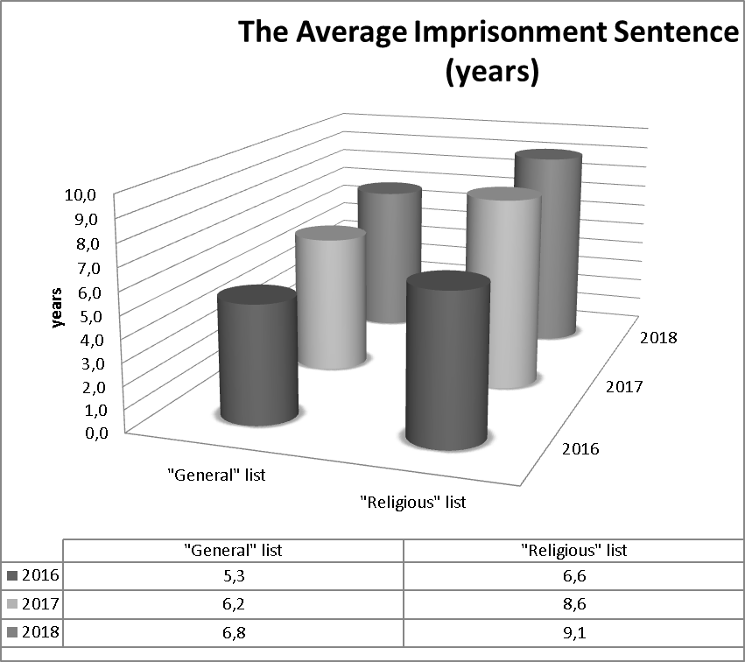
For instance, if two years ago an average term for convicted political prisoners, who were included in the "general" list (not to take into account the two people, who got convicted and got the life sentence) was approximately 5 years and 3 months, then in the year of 2017, it consisted of approximately 6 years and 2 months, and as of now it has become 6 years and 10 months. The deterioration of the situation with those political prisoners, who have been included in the "religious" list is equally just as serious: an average term of their imprisonment/deprivation of freedom has increased from 6 years and 7 months in the year of 2016 up to 8 years and 7 months in 2017, and as of today it has become up to 9 years and 1 month.
Nevertheless, the practice of the past year has indicated that the endemically large - scaled public pressure when applied against Russian authorities can yield some results, at the very least in the most egregious cases of politically motivated criminal prosecution.
In the past period:
- the representatives of the Crimean Tatar nation: Ilmi Umerov and Ahtem Chiyhoz, who were the members of Majlis for the Crimean Tatar People, which has been deemed as am extremist organization without any grounds to back that accusation up, have been pardoned with the help of mediation carried out by the Government of Turkey;
- the criminal prosecution of Dmitry Bogatov, who has been persecuted based on the charges filed against him accusing him in calling for terrorism and mass riots, solely on the grounds of the fact that he supported the output node of the TOR network on his computer, have been dropped;
- Yuri Dmitriev has received an acquittal as a final sentence in his case;
- for those accused in the case of the "New Greatness" /«Нового Величия» - A. Pavlikova and M. Dubovik the measure of restraint has been changed.
And virtually, in connection with all of these cases, there have been campaigns of using public pressure within Russia going on, as well as the international pressure that has been applied upon Russian authorities from outside. And as one might have expected all that did impact the final outcome in these cases.
One can consider the following to serve as instruments of international pressure of the same nature in the future:
• A special attention that is paid to the cases of politically motivated criminal prosecution in the RF, particularly in regards to the cases of political prisoners, the demand for the release of individuals, who have been deprived of jailed/their freedom, who have been prosecuted based on apparently fraudulently fabricated charges against them and / or solely on the grounds of their political, religious or other convictions, and on the basis of their non - violent exercise of their right to the freedom of thought, conscience and religion, freedom of expression of their points of view and information, freedom of peaceful assembly and association, and the other rights and freedoms guaranteed by the international obligations undertaken by the Russian Federation;
• A demand to abolish all of the anti - constitutional standardized norms of the Criminal Code of the Russian Federation, as well as all of the norms of the criminal law that violate the international obligations undertaken by the Russian Federation: Art.212.1 of the Criminal Code of the Russian Federation; Art. 284.1 of the Criminal Code of the Russian Federation, as well as all of the amendments adopted in the legislation that have established the status of "undesirable organization"; article 330.1, and also cancel out all of the changes in the legislation that established the status of organizations acting in the capacity and carrying out the functions of a foreign agent;
• A demand to provide a broken down in greater detail and narrowed down legislative definition as well as the restrictions in the practical application of the extremist activity, as well as the art. 280, art. 282, art. 282.1, art. 282.2, art. 282.3 of the Criminal Code of the Russian Federation;
- An imposition of specific, personally tailored sanctions against those
individuals, who are personally responsible for gross violations of the human rights and having to do with the illegal, politically motivated imprisonment/deprivation of freedom.

One can get additional informational materials, which are depicting the situation on political repressions as well as on the political prisoners in Russia in much greater detail, and which are also available in the English language as well on the website of the HRAC "Memorial" - http://memohrc.org/en/content/programma-podderzhka-politzaklyuchennyh-i - drugih-zhertv-politicheskih-repressiy. Also, if you wish to inform us about your desire to receive more news on this topic in either Russian or English language, you can notify us about it at: press@memohrc.org.

